**Integrity Shippers: Global Expansion in the Logistics Industry**

Aditi was immersed in a high-stakes analysis for Integrity Shippers, a domestic freight transportation company, as an internal strategy consultant at Integrity Shippers was at a critical juncture. The company’s rise in India had solidified its position as a market leader. In order to sustain growth and maximize shareholder value, an international expansion seemed like the next necessary and imperative step.

The board had narrowed down the potential markets to three major countries: the United States, Canada, and Dubai. Each presented a unique set of opportunities and challenges. Aditi’s task was to dissect these options, weigh the risks and rewards, and ultimately recommend the optimal path forward. The clock was ticking. With every passing day, the competitive landscape was evolving. Aditi knew that her analysis would be instrumental in shaping the company’s future. The weight of this responsibility was immense, but she was determined to deliver a comprehensive and actionable strategy. She had to present her final analysis and recommendations at the next board meeting.

**History of the Company**

Integrity Shippers, a Bangalore-based company founded in 2007 by IIM Trichy alumni Arjun Mehta and Ananya Kapoor is a leader in India’s trucking industry. Initially, the company started as a small logistics firm with a fleet of just 50 trucks, focusing on providing reliable and timely transportation services across South India.

In its early years, Integrity Shippers faced stiff competition from established players, but its commitment to reliability and transparency began to set it apart. By 2010, the company had expanded its operations nationwide, doubling its fleet and implementing a basic digital platform that allowed shippers to track their consignments in real-time - a first in the industry at the time.

The turning point came in 2012, when Integrity Shippers introduced a state-of-the-art, GPS-enabled fleet management system. This innovation significantly reduced the operational inefficiencies that plagued the industry. The company’s focus on technology-driven solutions allowed it to scale rapidly, attracting major clients from different sectors. By 2015, Integrity Shippers had secured a 15% market share in the Indian freight transportation industry, becoming one of the top three players in the market.

The introduction of an integrated digital platform in 2016 marked another milestone in the company’s history. This platform not only connected shippers with truck owners more efficiently but also introduced dynamic pricing models, which optimized costs for clients and ensured higher utilization rates for truck owners. Today, Integrity Shippers boasts a vast network of over 30,000 verified trucks and continues to lead the industry with its cutting-edge digital infrastructure. The company’s reputation for delivering goods on time, every time, has solidified its position as the market leader in India, with a current market share of 30%. As it looks to the future, Integrity Shippers is poised to take its success story beyond the borders of India, eyeing international expansion as the next frontier.

**Market Expansion Analysis**

As Integrity Shippers considers international expansion, Aditi’s focus shifted toward three key markets: Dubai, the United States, and Canada. Each of these markets offers unique opportunities and challenges, with varying levels of market favorability, regulatory environments, workforce availability, and associated costs. To ensure a data-driven decision, Aditi compiled probabilities and cost estimates for each market, carefully weighing the potential return on investment and strategic fit. The expected set-up costs for expansion into Dubai is ₹50 crores, US is ₹75 crores and Canada is ₹65 crores. Furthermore, a constant 14% interest rate across all forecast years and a 30% corporate tax rate across all regions have been assumed for the financial analysis. Additionally, it was assumed that 15% of the net income **(Exhibit 1)** generated in India would be the projected net income for Year 1 in whichever region Integrity Shippers chooses to expand. This would provide a conservative yet realistic financial benchmark as the company establishes its presence abroad.

**Dubai: Gateway to the Middle East**

Dubai represents a strategic entry point into the Middle East and North Africa (MENA) region. The market offers a 60% chance of favorability, with regulatory conditions favorably leaning at 80%. The city’s status as a global logistics hub and its rapidly developing infrastructure makes it an attractive option. However, Dubai’s workforce poses a moderate challenge, with only a 70% likelihood of securing adequate talent locally.

In terms of costs, favorable regulations in Dubai would result in setup expenses of ₹2 crores, while navigating less favorable regulations would push the costs to ₹4 crores. Workforce expenses are significant: hiring locally would cost ₹6 crores, while importing talent from India would require ₹8 crores. Despite these costs, Dubai’s strategic advantages and regional potential make it an appealing prospect for Integrity Shippers.

**United States: The Largest Market with High Competition**

The U.S. presents the largest market opportunity with an 80% likelihood of favorability. The regulatory environment, though slightly more restrictive with a 60% favorability rate, aligns well with Integrity Shippers' experience in managing complex logistics challenges. The U.S. also offers the highest probability (80%) of securing a skilled workforce, critical for ensuring operational efficiency.

However, these advantages come with higher costs. In a favorable regulatory scenario, the company would incur ₹4 crores, escalating to ₹7 crores if regulations are less accommodating. Additionally, labor costs are steep, with local hiring costing ₹7 crores and sourcing talent from India costing ₹10 crores. While the U.S. market is highly competitive and saturated, the sheer size and technological advancements offer a lucrative growth avenue.

**Canada: A Conservative but Stable Option**

Canada offers a middle ground with a 70% market favorability rate and a stable regulatory environment (70% favorability). Workforce availability is slightly lower at 60%, reflecting the challenge of finding specialized logistics talent in a market dominated by established players.

The cost implications in Canada are moderate compared to the other markets. High regulatory favorability would require an investment of ₹3 crores, increasing to ₹6 crores under less favorable conditions. Labor costs are similar to those in the U.S., with local hiring pegged at ₹7 crores and recruiting from India at ₹9 crores. Although the Canadian market is smaller, its stability and proximity to the U.S. provide strategic benefits, making it a feasible expansion option with less volatility.

**Conclusion**

After thoroughly analyzing the three markets, Aditi recognizes that each option presents distinct advantages and challenges. While Dubai offers strategic access to the MENA region at moderate costs, the U.S. provides unmatched market potential despite high expenses. Ultimately, her recommendation hinges on balancing immediate growth opportunities with long-term strategic positioning, knowing that this decision will shape Integrity Shippers' global footprint.

**EXHIBIT 1: Balance Sheet - Standalone-Abridged-Actual - [INR-Crores]**

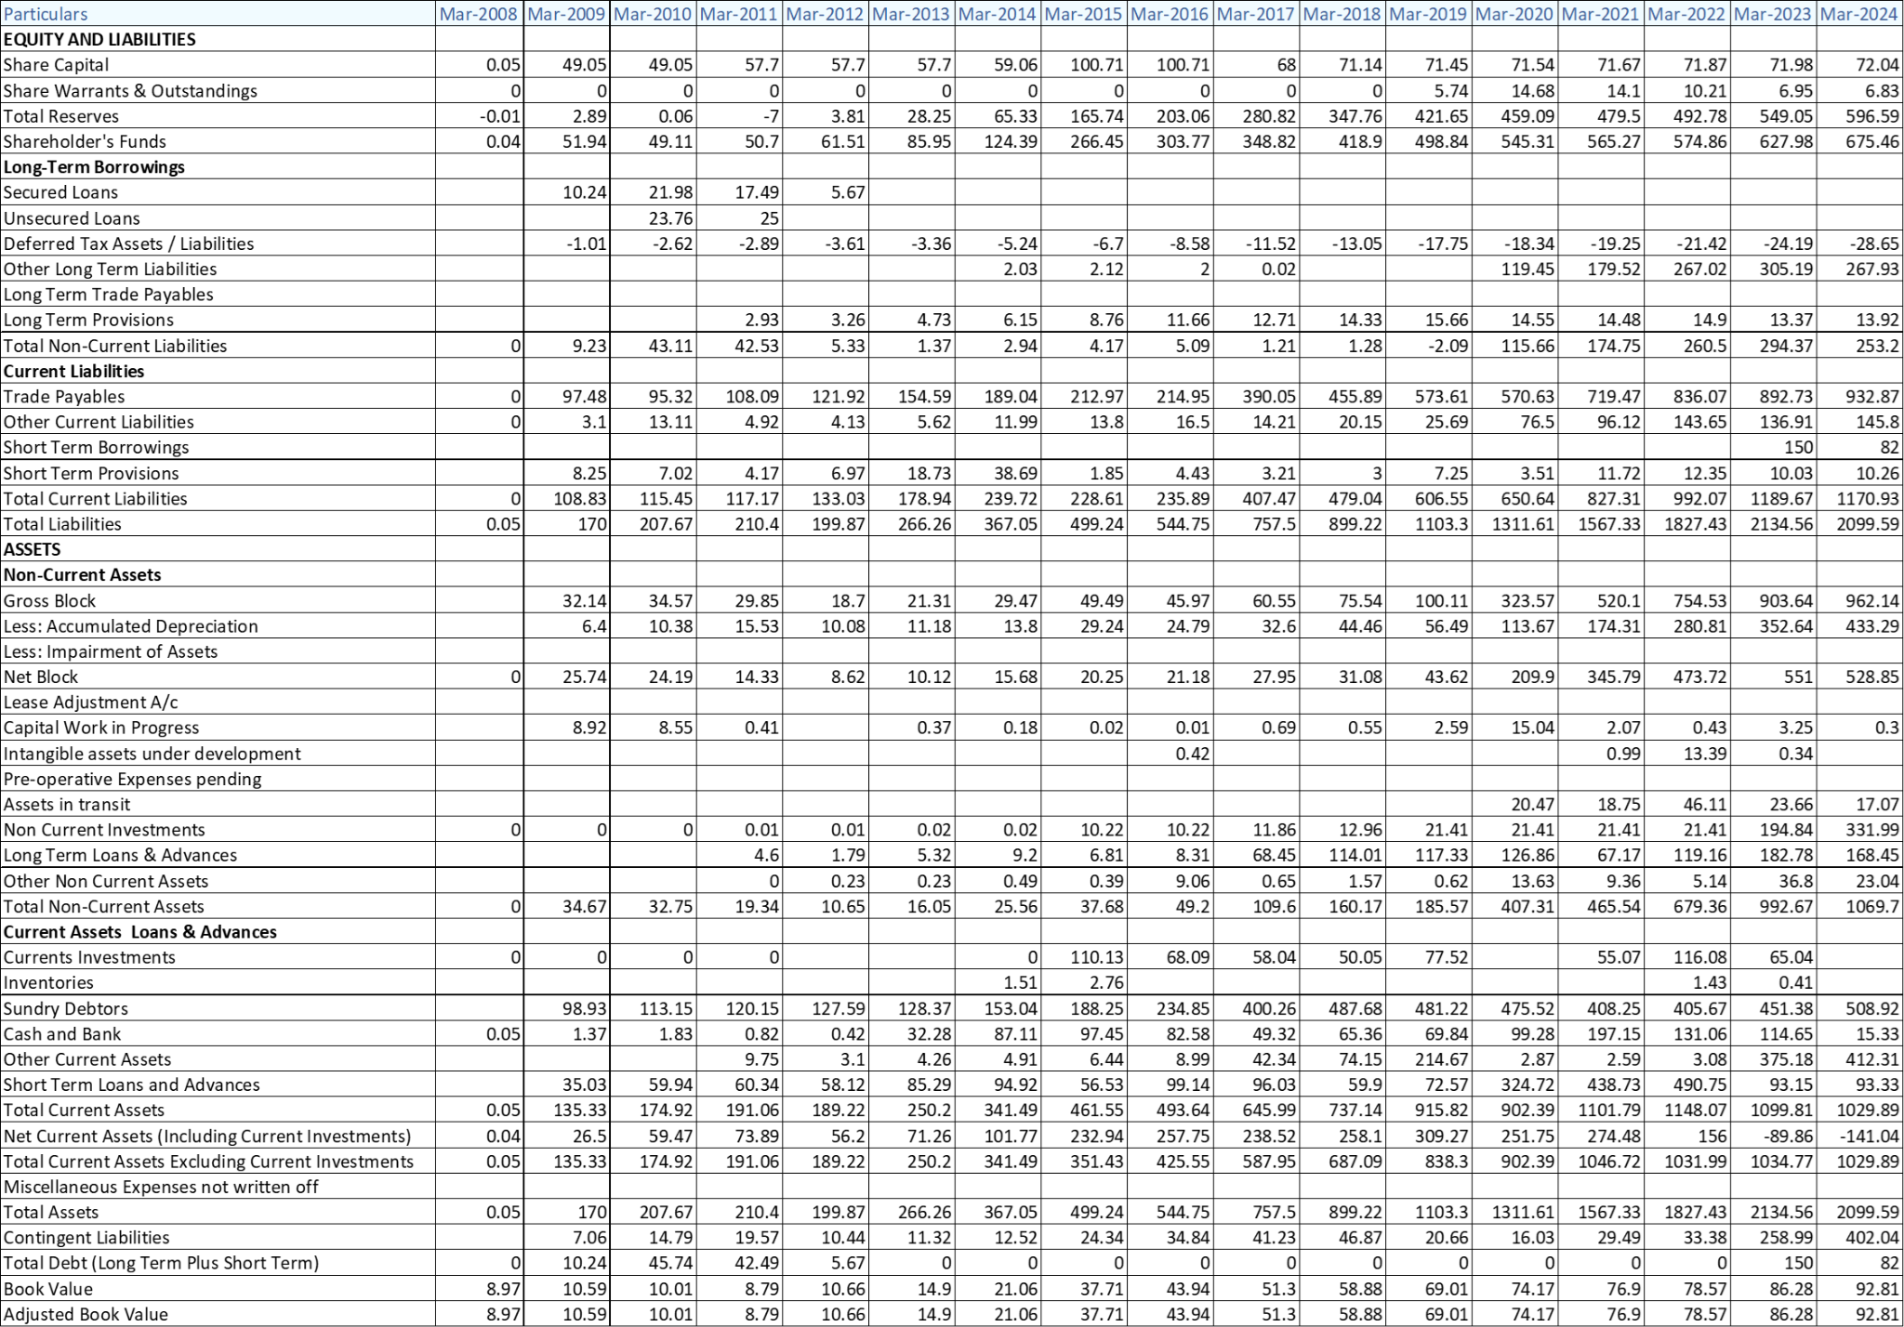

***Source:***[*https://www.aceequitynxt.com/*](https://www.aceequitynxt.com/)

**EXHIBIT 2: Balance Sheet - Standalone-Abridged-Actual - [INR-Crores]**

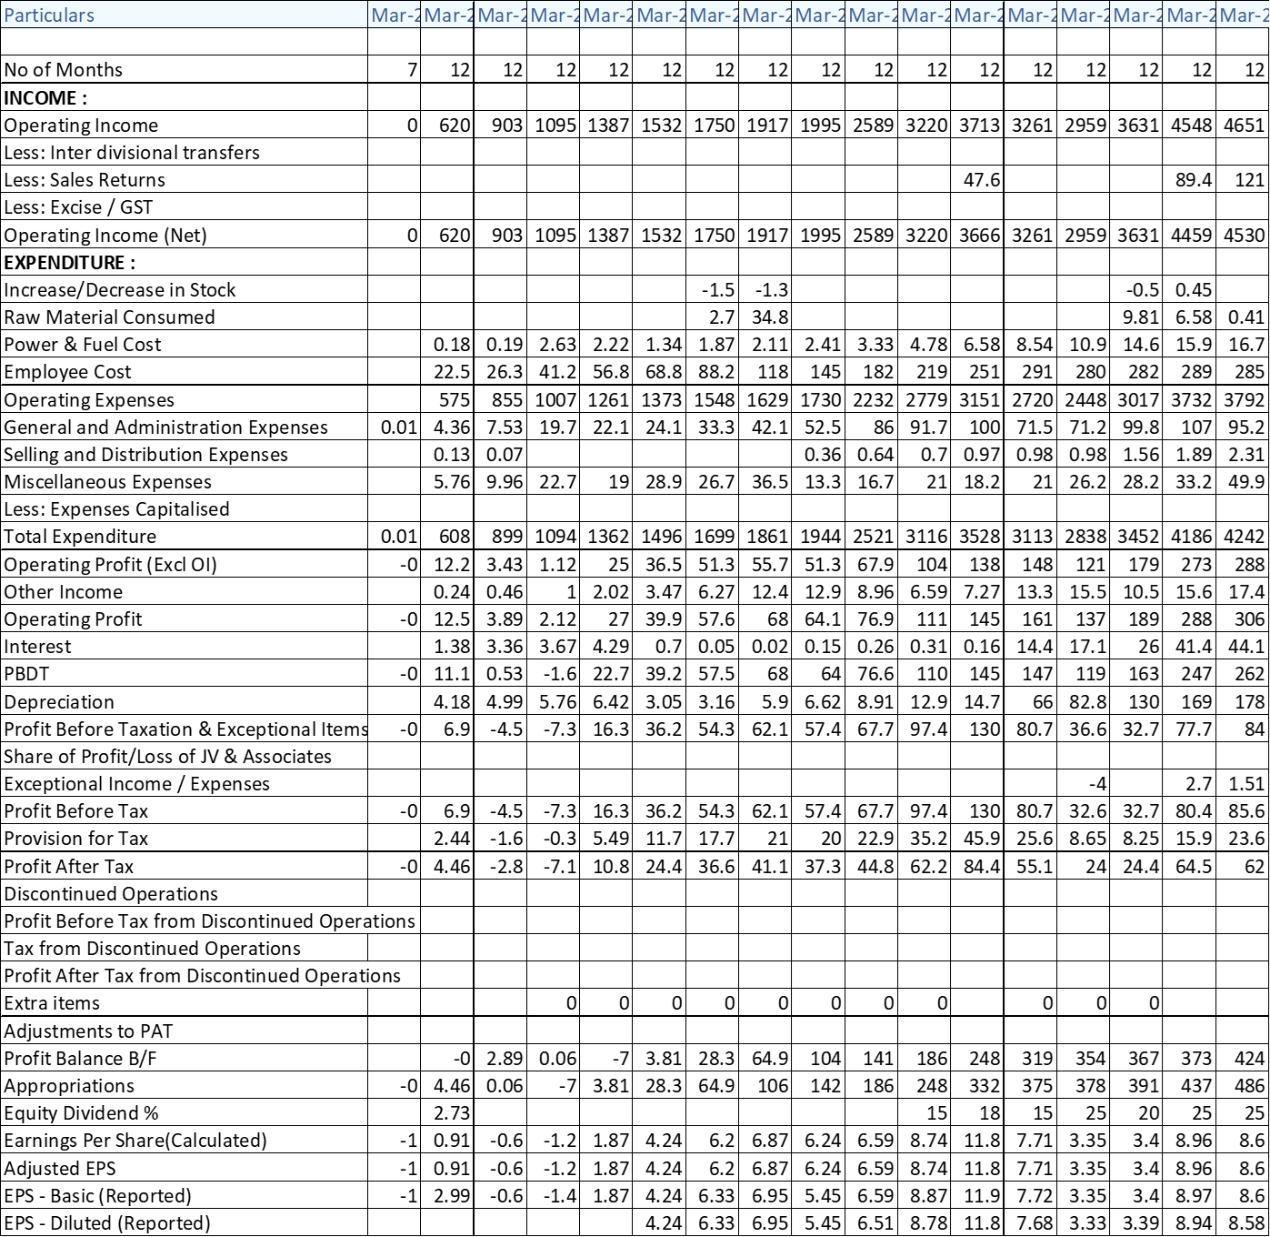

***Source:***[*https://www.aceequitynxt.com/*](https://www.aceequitynxt.com/)

**EXHIBIT 3: Inflation Rate for the past 20 years in Dubai, US and Canada**

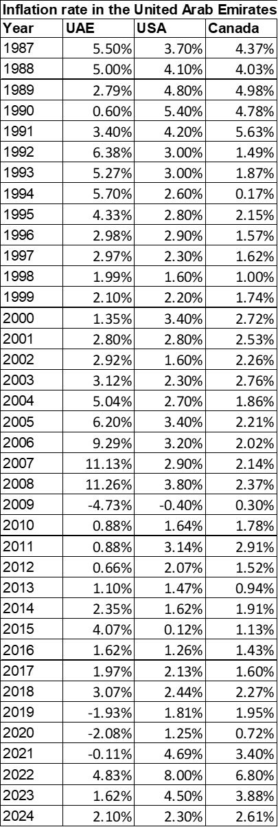

***Source:***[*https://www.statista.com/*](https://www.statista.com/)